THE UNIVERSITY OF AZAD JAMMU AND KASHMIR
Department of Software Engineering
LAB TASK 01
NODE.JS INSTALLATION AND
PLAYWRIGHT SETUP

INSTRUCTOR NAME:ENG.R FAHAD NISAR

STUDENT NAME : FARYAL RASHID
ROLL NO : 2024_SET_23
SESSION : 2024_2028

Step 1: Install Node.js
Node.js is a JavaScript runtime that allows JavaScript programs to run outside a web browser. It provides the environment required to execute JavaScript-based testing tools such as Playwright.
Purpose:The purpose of this step is to install Node.js and npm on Windows 10 so that JavaScript projects and testing dependencies can be managed..
Screenshot 1 :Capture the Node.js installation or installation completion screen.

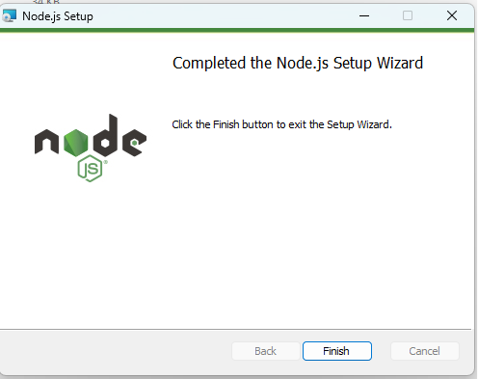

Step 2: Verify Node.js and npm
npm (Node Package Manager) is used to install and manage JavaScript project dependencies. Verifying the versions confirms whether Node.js and npm are accessible from the Command Prompt.
Purpose :The purpose of this step is to confirm that Node.js and npm have been installed and configured correctly.
node –version

npm –version

SCREENSHOT 2: Node.js and npm version verification

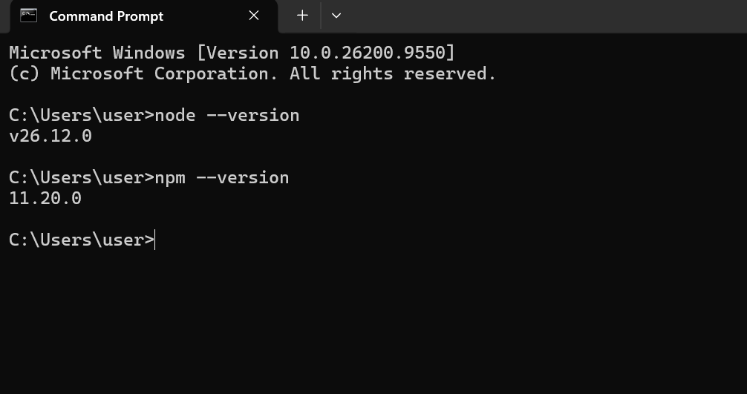

.

Step 3: Create the Project Folder
A project folder provides a dedicated location for storing source files, configuration files, dependencies, and testing results. Organizing project files in one directory makes development and testing easier to manage.
Purpose: The purpose of this step is to create a separate directory for the Software Testing Lab project.
To verify the current directory, execute:
mkdir software-testing-lab

cd software-testing-lab

SCREENSHOT 3: Project folder creation

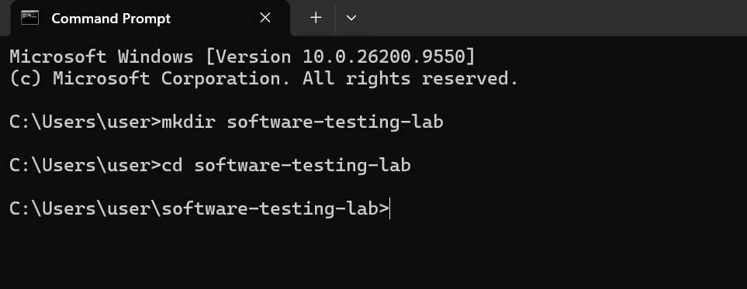

Step 4: Initialize the Node.js Project
Project initialization creates a package.json file containing essential project information, scripts, and dependency details. npm uses this file to manage the project's packages and configuration.
Purpose :The purpose of this step is to initialize the Node.js project and generate its package configuration file. While inside the project folder, I ran the following command:
npm init -y
SCREENSHOT 4: Node.js project initialization
SCREENSHOT 5: Playwright setup
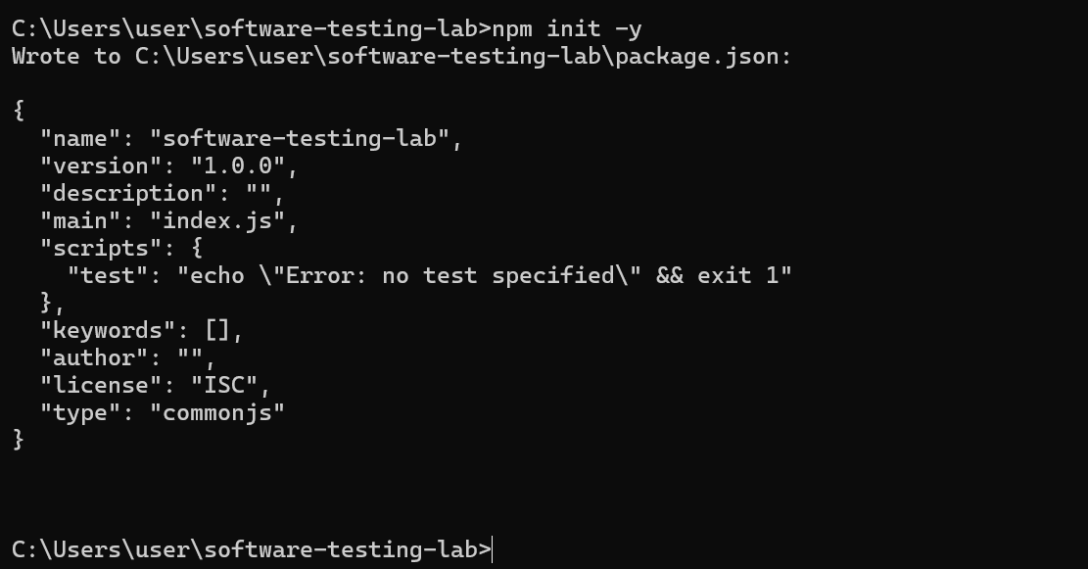.

Step 5: Install and Initialize Playwright
Playwright is a browser automation and end-to-end testing framework used to test web applications automatically. It supports browser interactions and allows testers to verify application functionality through automated test scripts.
Purpose :The purpose of this step is to configure Playwright with JavaScript and generate the necessary test files and browser configuration.
npm init playwright@latest

SCREENSHOT 5: Playwright setup

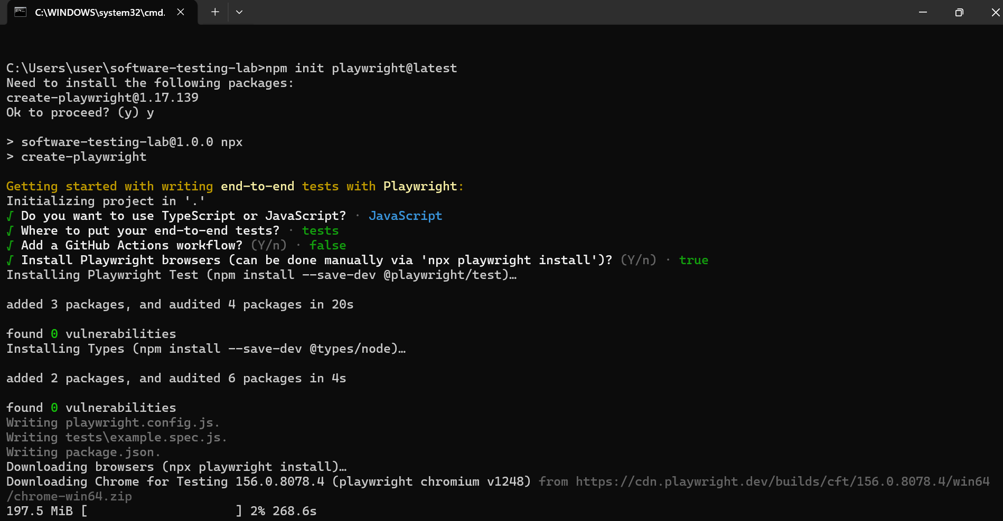

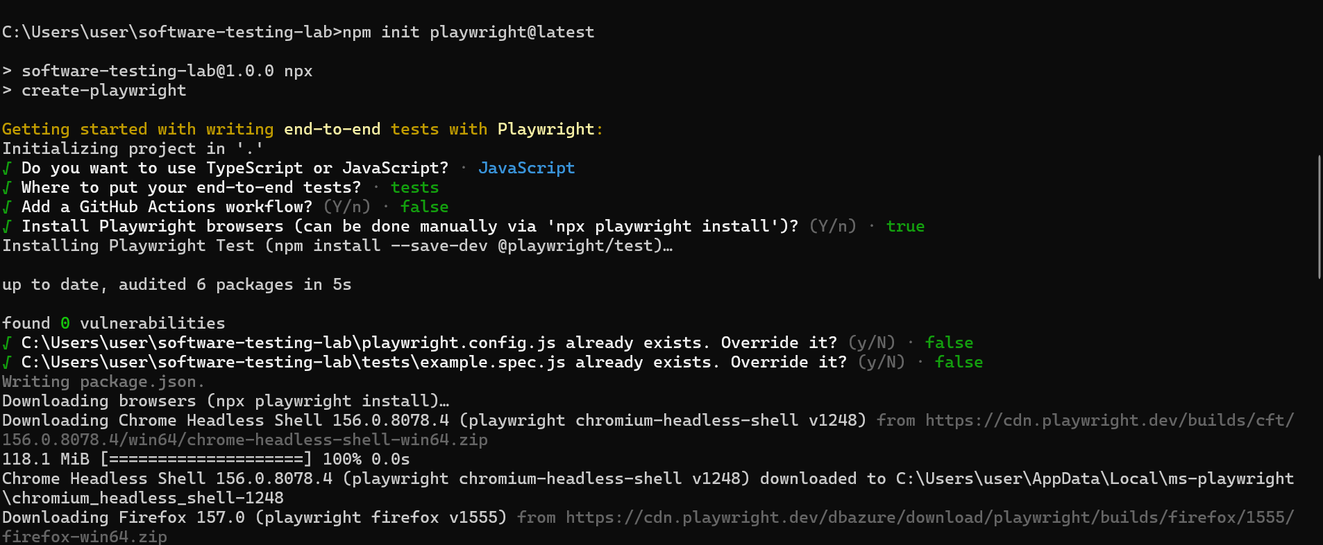
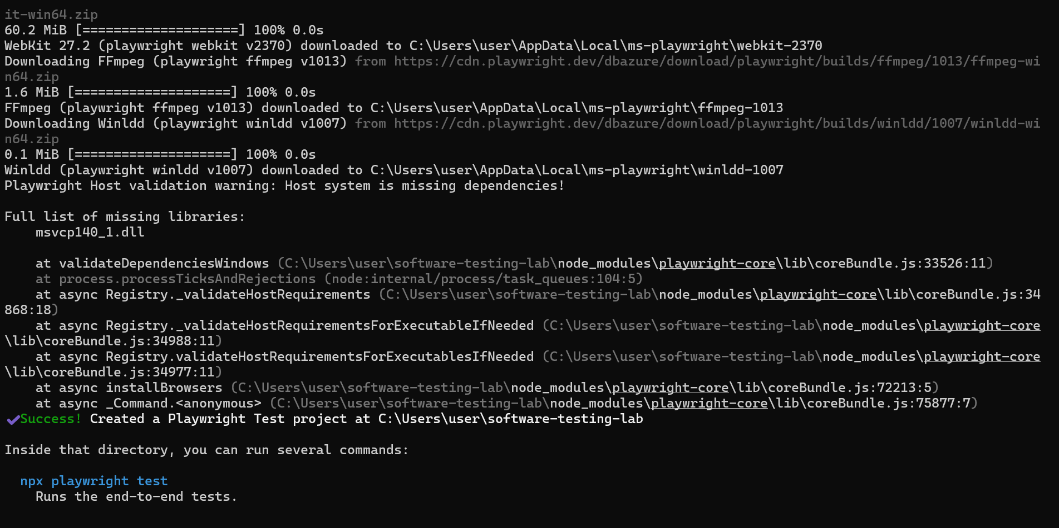
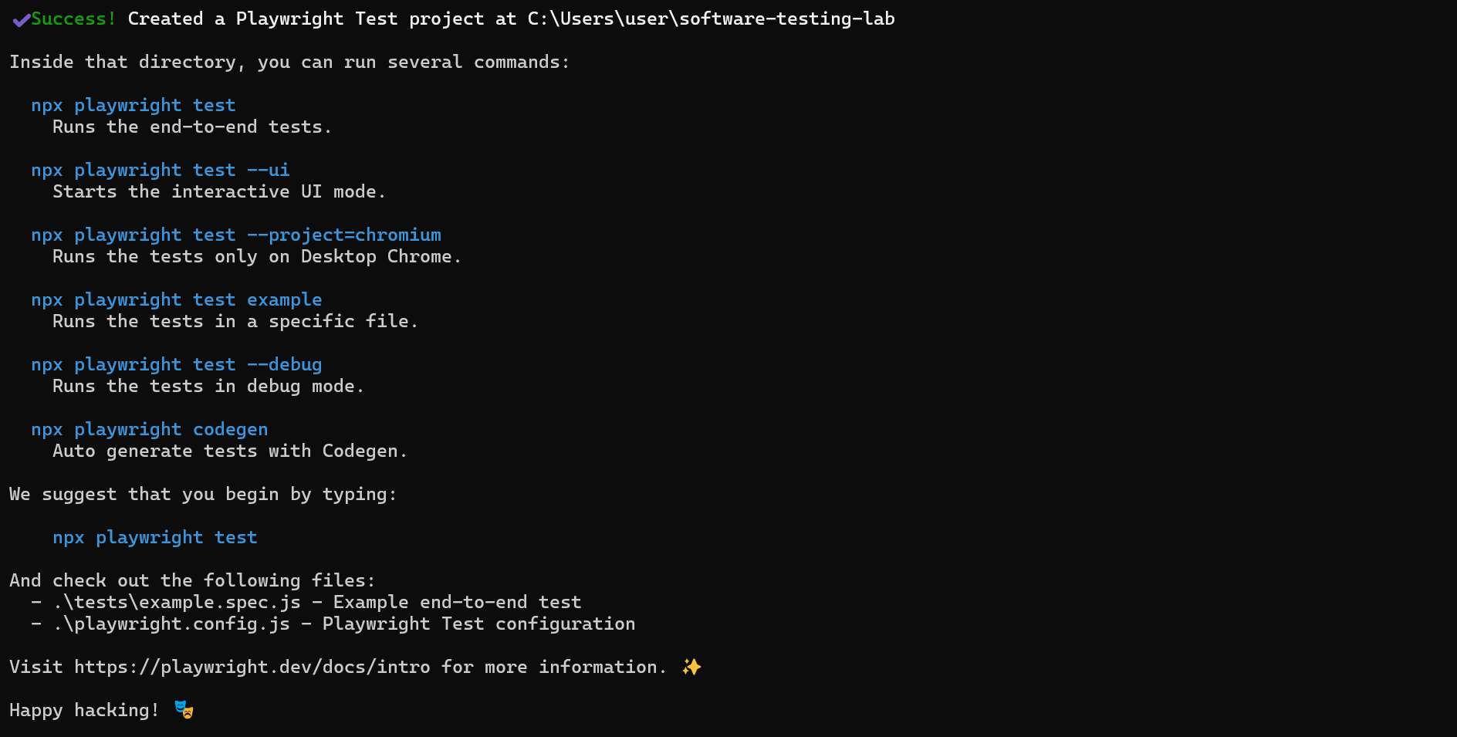

Step 6: Inspect Project Files and Verify Playwright
Playwright generates configuration files, test scripts, and dependency records during initialization. Inspecting these files helps verify that the project structure is correct and the testing framework is installed.
npx playwright –version

Purpose :The purpose of this step is to inspect the generated project files and verify the installed Playwright version.
.

Step 7: Execute the Sample Tests
Automated tests execute predefined steps to verify the expected behavior of a web application. Playwright runs test scripts in supported browsers and reports whether each test passes or fails.
npx playwright test

npx playwright test --project=chromium –headed
Purpose :The purpose of this step is to execute the generated sample tests and verify that Playwright is functioning correctly.

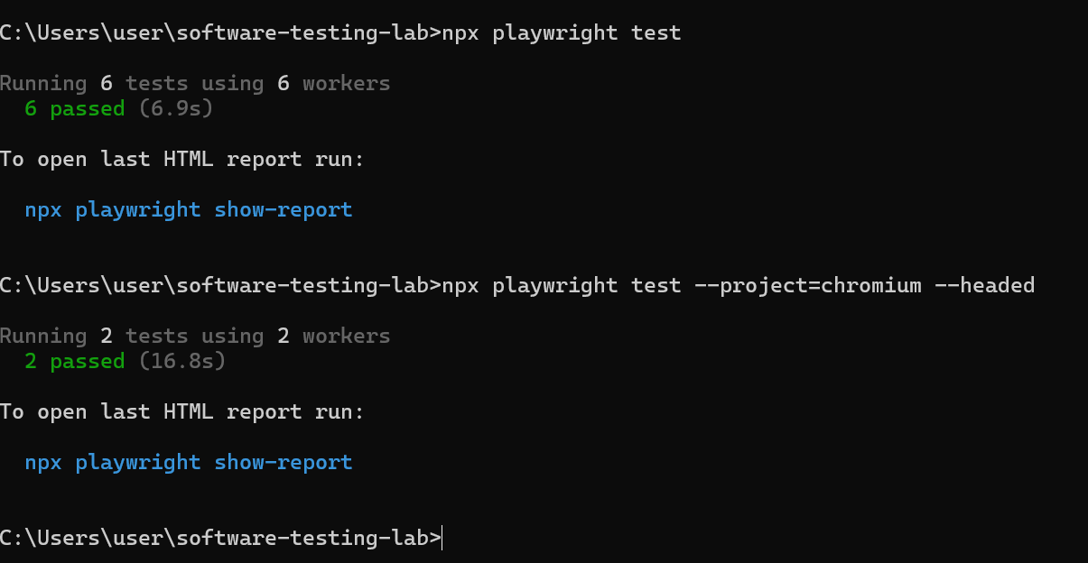

Step 8: View the HTML Report
Playwright generates an HTML report containing test execution details and results. The report provides a convenient visual interface for reviewing passed tests, failed tests, and other execution information.
npx playwright show-report

Purpose : The purpose of this step is to open the HTML report and review the results of the executed sample tests.

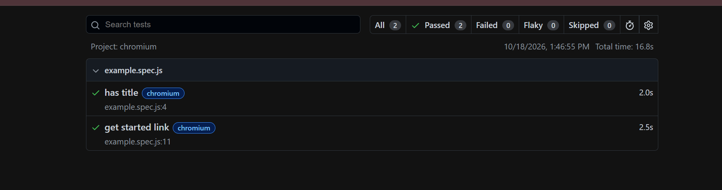

RESULTS
Complete the table below using the actual results from your computer. Do not guess or copy version numbers from another system.
Verification item | Actual result
Node.js version | v26.12.0
npm version | 11.20.0
Playwright version | Version 1.64.1
Playwright test summary | 6 passed (all configured browsers)
Chromium headed test summary | 2 passed, 0 failed

Conclusion
In this lab task, Node.js and npm were installed and verified on Windows . A Node.js project was initialized, and Playwright was configured using JavaScript. The generated project files were inspected, the sample tests were executed, and the HTML report was reviewed to examine the test results.

PROJECT REPOSITORY
Repository URL:https://github.com/Faryal-Rashid/Software-testing-lab
Before uploading the project, exclude node_modules. Include the project files and configuration required by the lab task. Check that the repository link can be opened before submitting it to the lab instructor.

